To create a transfer:
- Head to https://eqtrans.gfps.k12.mt.us
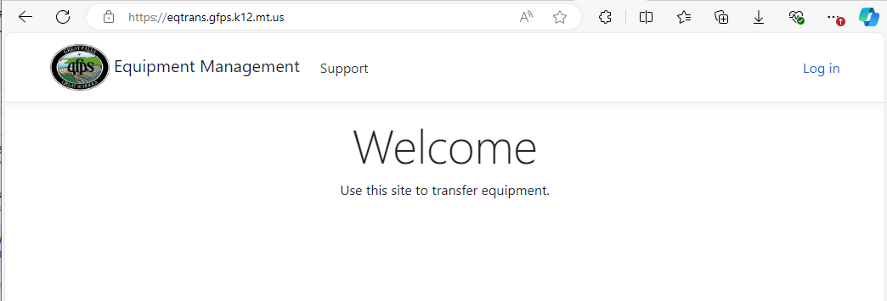
- Click “Log in” in the upper right corner if needed.
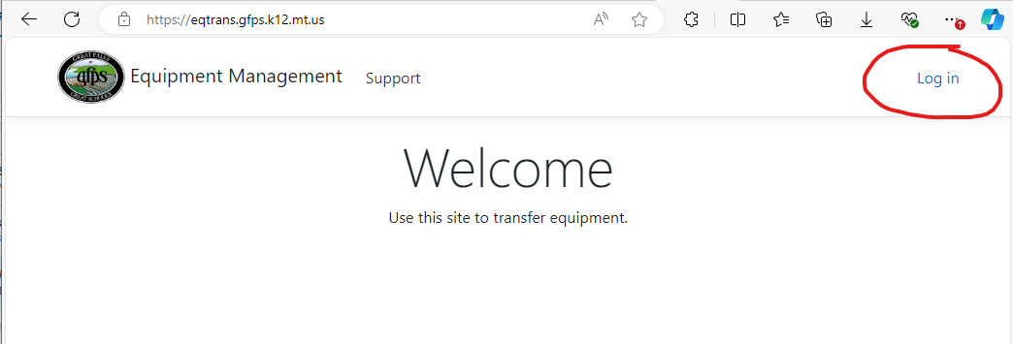
- Use your AD Credential to Login.
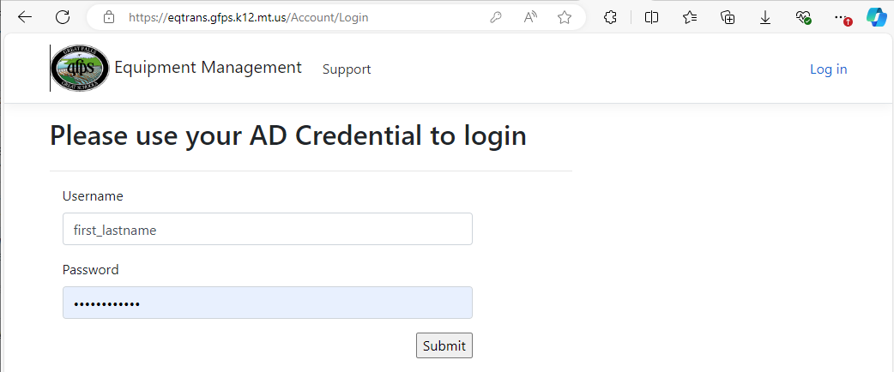
- Head to “Transfer -> Create Transfer”.
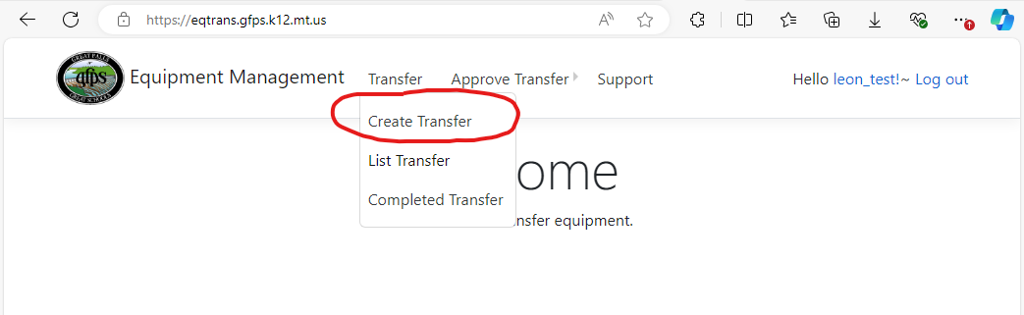
- Fill out the form with the transfer information.
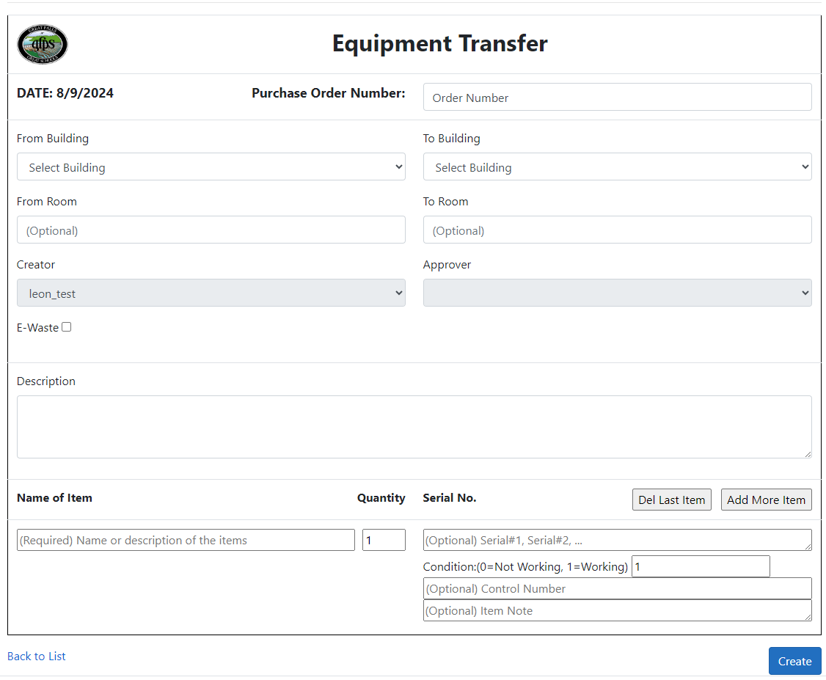
- Verify the information and click “Create” in the lower right corner.
- You should receive an email within the new few minutes about this transfer.

To approve a transfer.
- Head to https://eqtrans.gfps.k12.mt.us
- Click “Log in” in the upper right corner if needed.
- Use your AD Credential to Login.
- Head to “Approve Transfer -> List Transfer”.
- Find the Correct transfer click “Approve” on the right side of the page. (or click the link in the notification email you had received)
- Verify all the information is correct.
- Click “Approve” in the lower right corner of the page.
- You should receive an email within the new few minutes about this transfer.

To accept a transfer.
- Head to https://eqtrans.gfps.k12.mt.us
- Click “Log in” in the upper right corner if needed.
- Use your AD Credential to Login.
- Head to “Transfer -> List Transfer”.
- Find the Correct transfer with the Id click “Details” on the right side of the page. (or click the link in the notification email you had received)
- Scroll down and click the “Accept” button in the lower right corner.
- Verify all the information is correct and match the transfer you had received. Make any changes if necessary.
- Click “Submit” in the lower right corner of the page.
- You should receive an email within the new few minutes about this transfer.

